Assignment-2

- Handling Missing Values
Missing values in the Price column were handled using MEDIAN imputation. The median was chosen because it is less affected by outliers and helps maintain the overall data distribution while ensuring a complete dataset.

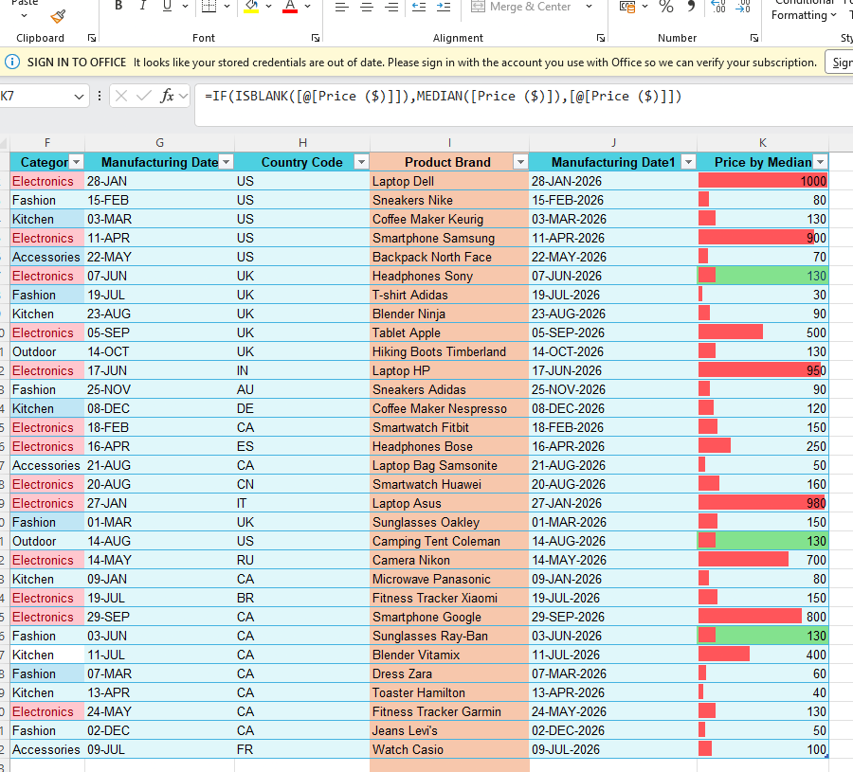

- Correcting Inconsistent Data
Using find and replace function to standardize the text formats in the "Product
Name" column and fix any typos or misspellings in the "Category" column.

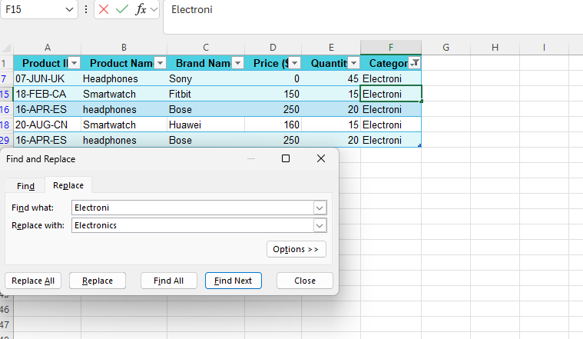

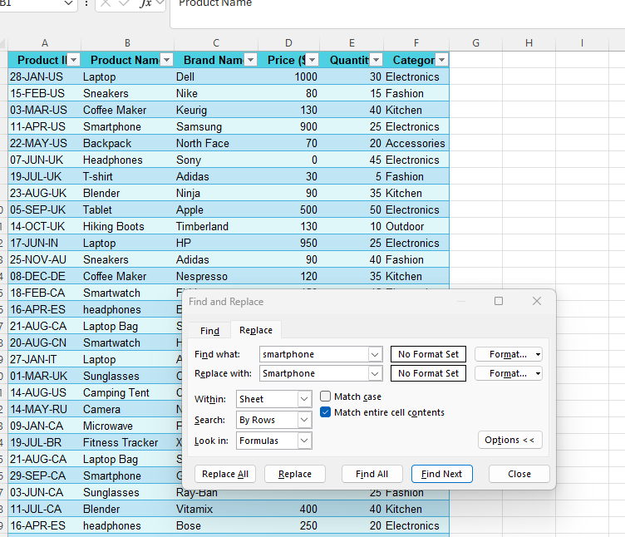

- Splitting and Merging Data
Split the "Product ID" column into two separate columns for Manufacturing Date"and "Country Code" using LEFT and RIGHT functions.

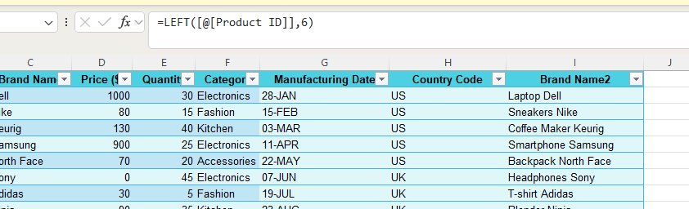

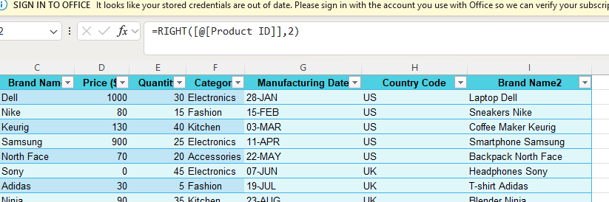
- Merge the "Brand Name" and "Product Name" columns into one column named "Product Brand" using CONCAT function.

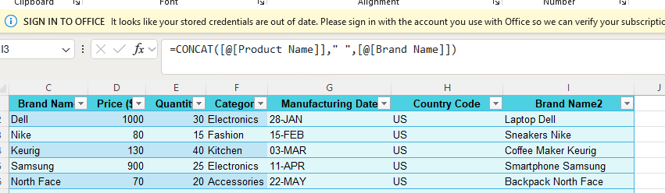

- Conditional formatting
Applied Data Bars or Color Scales conditional formatting to the Price column to visually compare values.
Created a custom conditional formatting rule in the Category column to highlight all cells containing "Electronics."

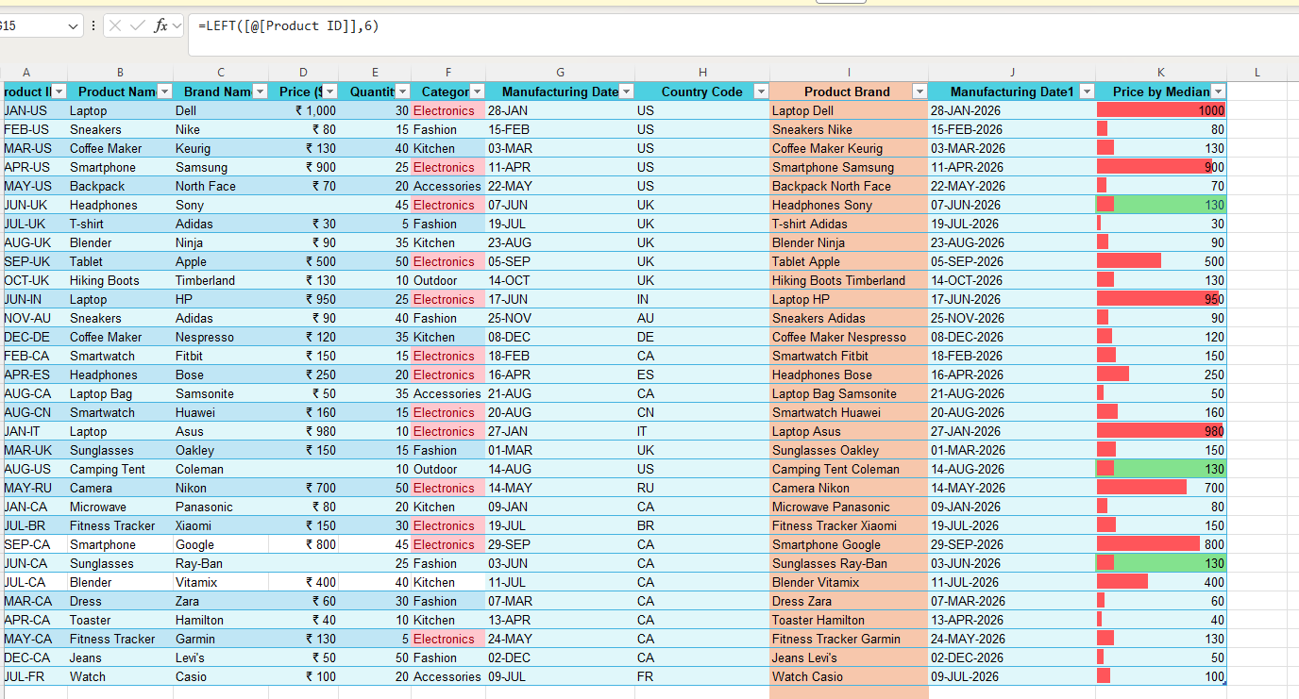
- Removing Duplicates
Identify the duplicate values using REMOVE DUPLICATES option to maintain the data set accurate. There are 3 duplicates were removed in the data set.


